**Workshop: Finding Objects, then classes, then**

**Model**

**Problem - Tourist places center**

The tourist travel agency company needs a system where it maintains a lot of variation of tourist places around the world, as data entry of how many people will travel in the tourist package, a total cost will be assimilated in the travel package made as a transport and also according to to the tastes of each client, it will depend on what options of tourist tastes the client chooses so that the system recommends the places most assimilated to the client's tourist tastes and so that the tourist can make a good decision on each trip they want to make.

**Overview**

In the digital world, new ways of optimizing this type of inconvenience are being implemented, giving positive results, there is a lot of competition with companies to offer digital services according to the tastes of the client, but to solve these needs there are pages which we can store places. most visited in an automated way so that the system and functions that implement payment services do not collapse, keeping accounts with each package price according to the number of clients who wish to travel and so that clients can form their travel plan in a very safe way and fast providing customer service with relevant information about your destination and the details

**Background**

A travel agency is a tourist company dedicated to the intermediation, organization and implementation of projects, plans and itineraries and elaboration and sale of tourist products among its clients and certain travel providers: such as: carriers ((airlines, cruises)), accommodation service (hotels,) with the objective of making tourism goods and services available to those who they want and can use them. Travel agencies are especially useful for hiring multi-day trips abroad, as they facilitate the procedures with the foreign companies and solve problems derived from accommodation and of the tourist guide. This is how travel agencies sell both tickets flights such as accommodation in different hotels,offering services both inside and outside the country. The added value they deliver, consists of putting together the so-called "tourist packages", which combine transfer and accommodation options with highly competitive prices. This agreements are reached with airlines and hotel chains, reserving in advance a large number of places. Oh sea, it's for through these agencies, that people can save a lot time and money in scheduling your vacation.

Tourist Package: is the set of services provided based on a previously organized itinerary, which is acquired in the form of a "block" at a single and global price.

Tourist resources: set of merchandise or products that are stored awaiting sale or marketing are "raw material" for attractions.types of tourist resources

Natural Resources: those associated with geography and

ecology, such as those related to beaches, the sea, the coast, the

climate, sun, , mountains, rivers, flora, fauna.

- Resources associated with leisure: existing facilities for practice of different types of sports.

- Cultural and historical resources: archaeological monuments,

religious, museums, among others.

- Resources for the celebration of Fairs, Congresses and Businesses.

- Infrastructure elements: the entire structure and

transportation parks, such as those of airlines, maritime,of roads… They allow tourists to enjoy the above and adapt the conditions in which the private components related to tourism activity.

- Accommodation and catering: facilities for accommodation and

feeding, as well as the elements related to both.

Cost table by agency

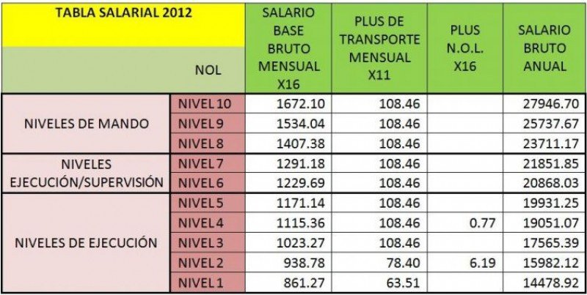

Analyst Comparison

ensure a good sales order so that the customer feels satisfied. This order is done by ensuring all the implements for a tusist trip such as transportation, places, food, hotels and destination places.

Inventory is the amount of productive resources that the company needs to carry out its activity. The inventory is different depending on the activity of the company. A purchasing or supply department is created, the main functions are:

• Establish provisions on the need for specific factors or materials.

• Development, evaluation and determination of the best supplier, price and delivery

• Acquisition of material on specific dates

• Checking the materials received and storing them.

Procurement management is established to obtain a competitive advantage.

Inventory functions

1. Ability to regulate the flow of inputs and outputs of materials without slowing down the activity of the company and supplier orders allow to regulate the outflows with the inflows.

2. Provide a stock of raw materials or materials to meet an anticipated customer demand.

3. Reduce the risk that production will stop due to not meeting customer demand due to lack of raw materials and reduce the breakdown of stock.

4. Protect from inflation and price variations.